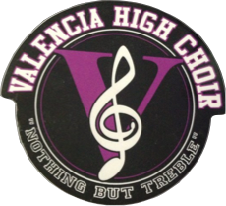
Valencia High School Sponsors Gift Donation

Valencia High School Choir is made up of over 180 students
in 6 different choirs.

Like most performing arts programs funding is tight. Financial support in the form of gift certificates, door prizes, food/beverages, or monetary donations from businesses and individuals like you at this time is critical.

We have multiple performances throughout the year including our Dessert Carol Night and Holiday Boutique in December.

Your gift is tax deductible under the IRS Code Section 170 (c) (1).

Thank you so much for supporting music excellence in the schools!

Sincerely,

